Serverless EC2 Instance Scheduler

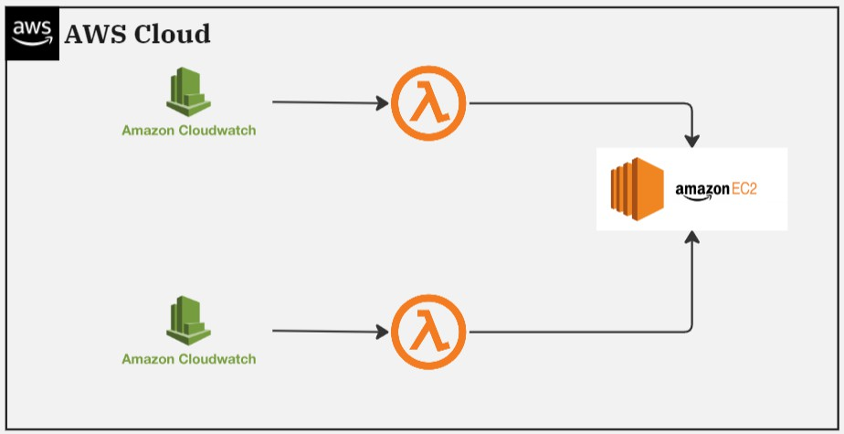
Some companies don't need their EC2 instances running all the time. They only need them during working hours. To handle this, I'll set up two simple functions using Lambda. One will start the instances in the morning, and the other will stop them in the evening. These functions will be triggered automatically by CloudWatch Events. And the best part? It's all serverless!
Step 1 :
➡Creating the Instance : Navigate to the EC2 Console. Follow the Outlined steps below

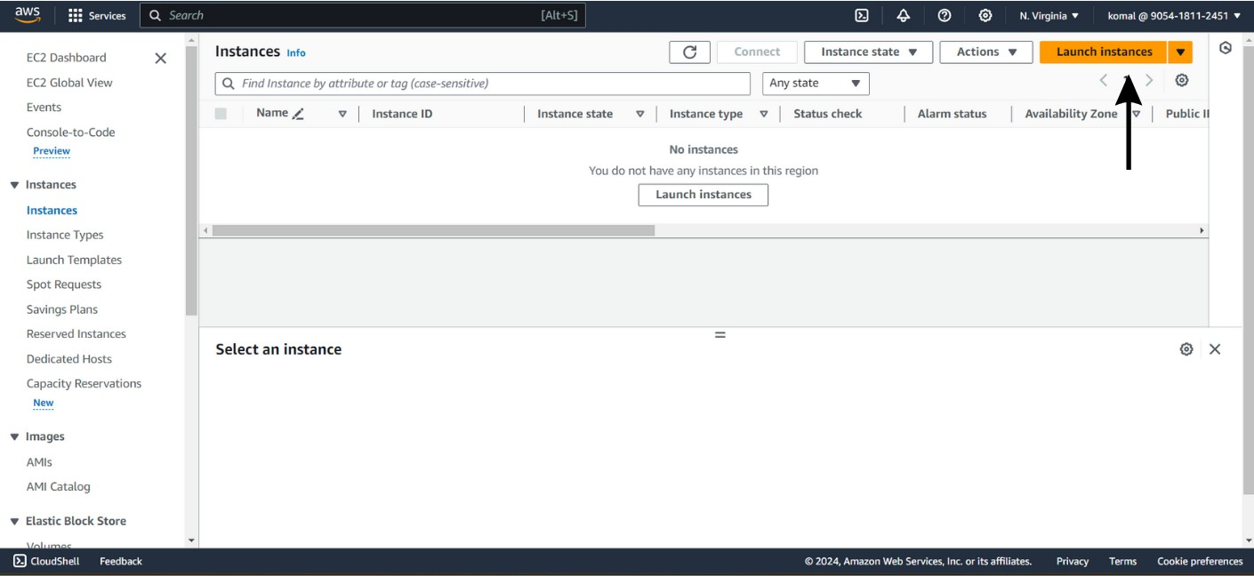

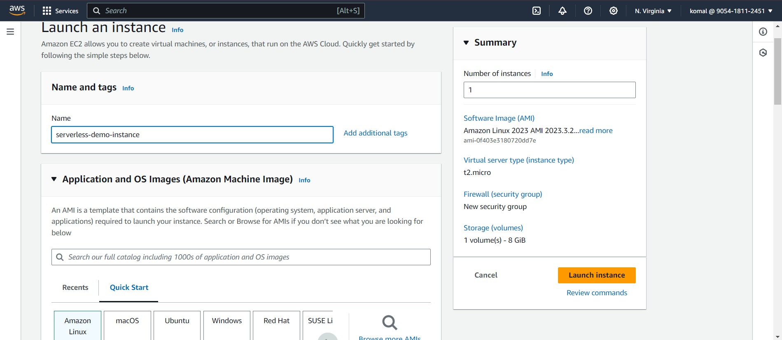

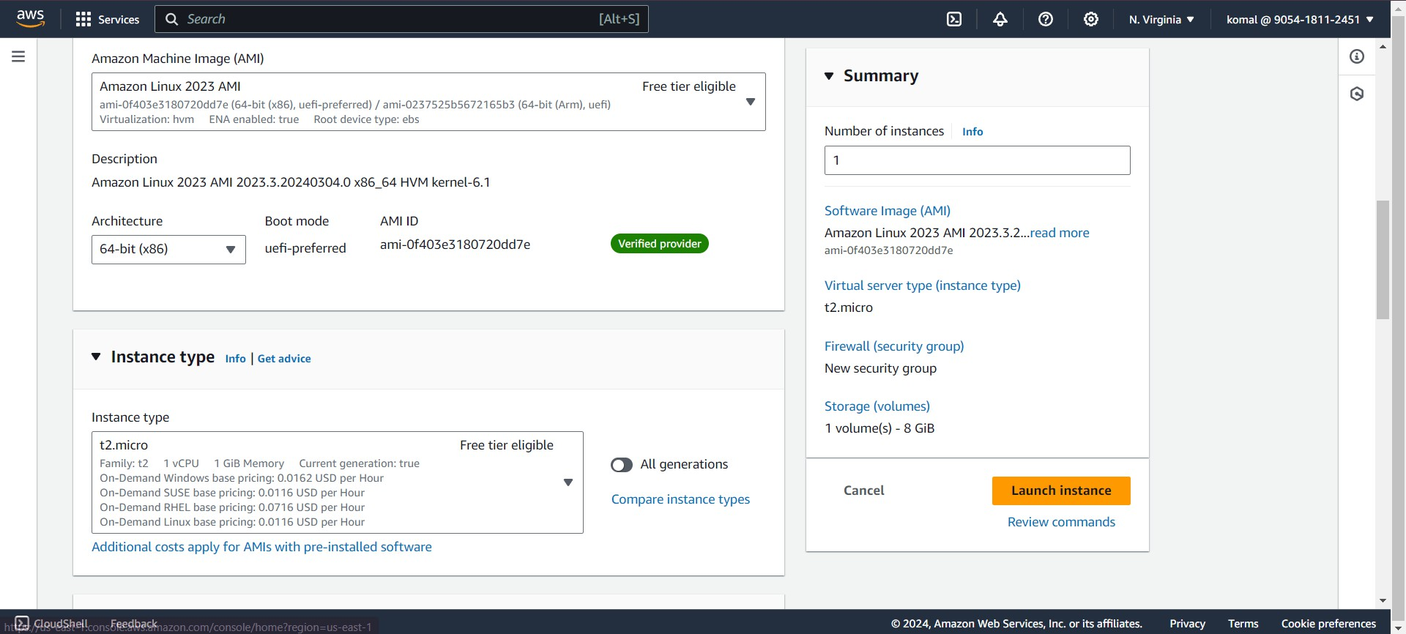
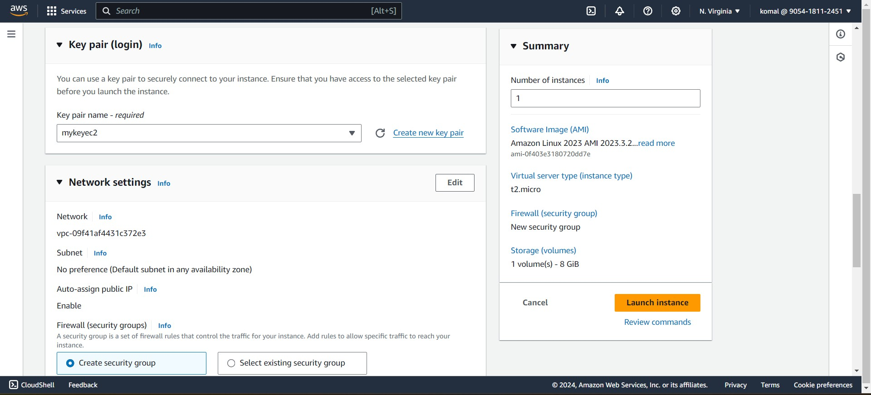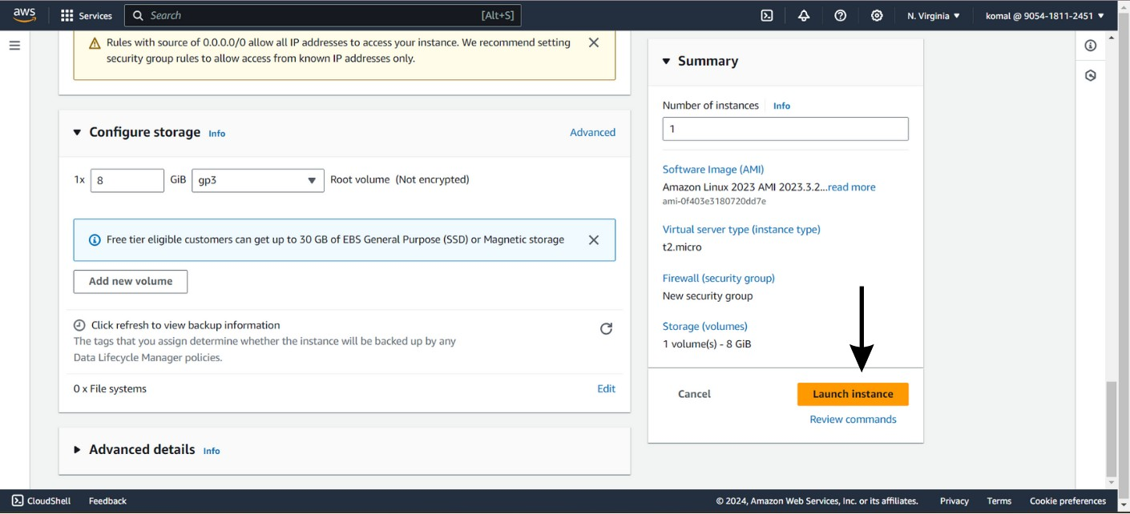
🌟Step 2:
➡Policy Creation:
- Go to the IAM Console.
- Select "Policies" and then click "Create policy".
- Select services as EC2.
- And Actions are DescribeInstances , StartInstances

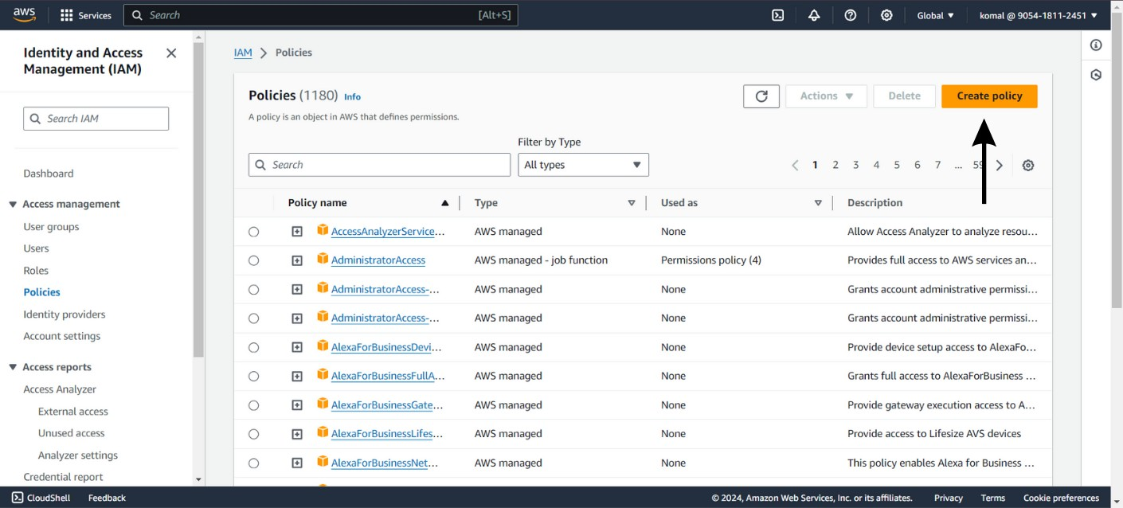

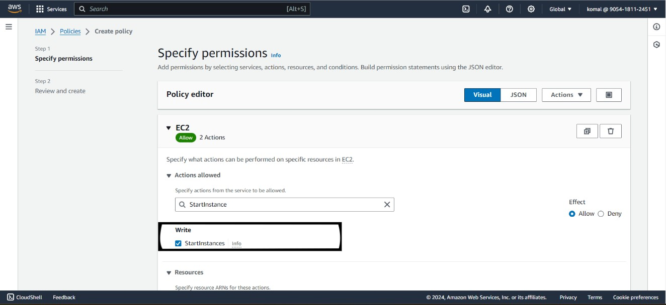

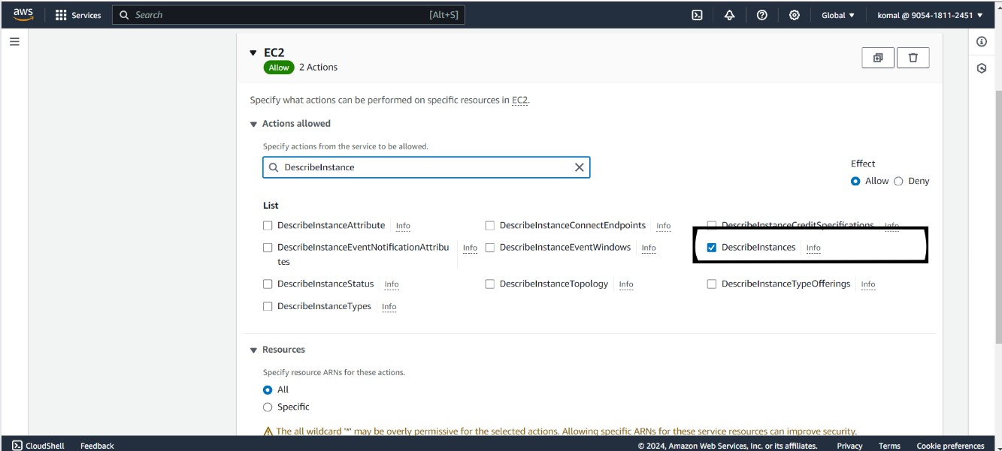

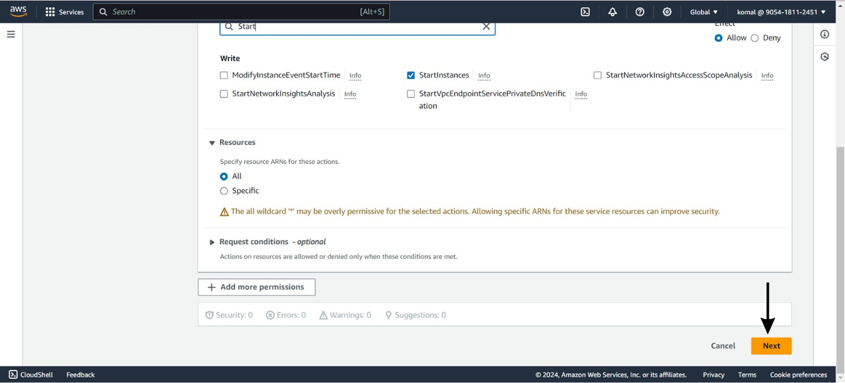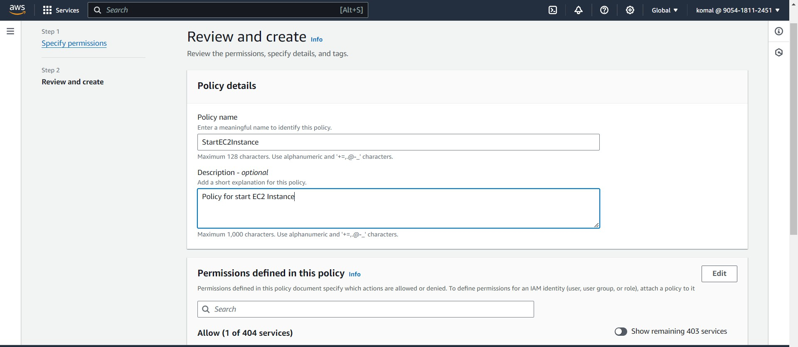

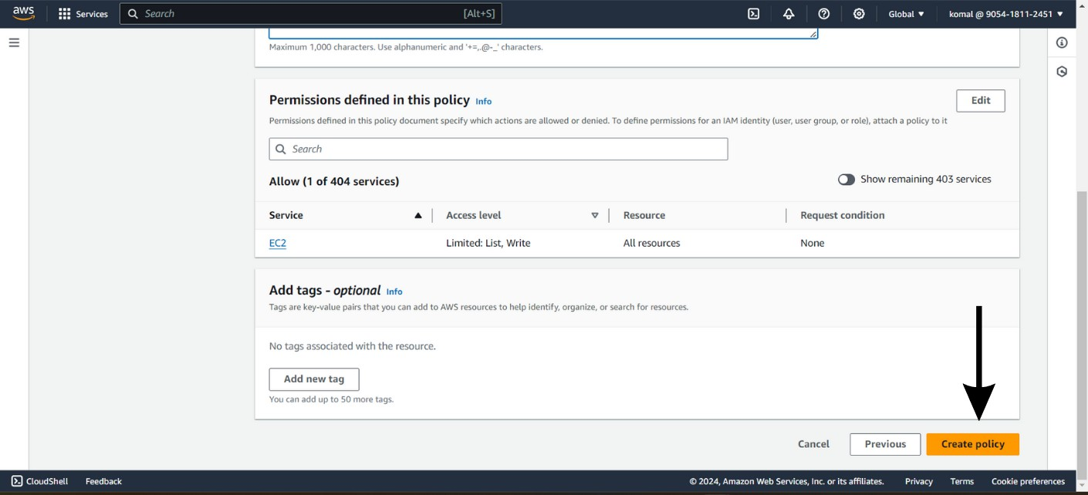

- After creating a policy for starting instances, we need to make a policy for stopping them too. Since we're making two Lambda functions, one for starting and one for stopping instances, each will have its own role. We'll attach these policies to their respective roles.

- Let's follow the same steps to create the Stopping Policy.

- The process remains identical, except for the Actions, as we're now focusing on stopping the instance.

- The Actions for stopping instances are DescribeInstances and StopInstances.

- Ensure your Policy name remains "stop-ec2-instance".
🌟Step 3:
➡Creating Lambda Functions:

- Go to the Lambda Console.
- Follow the outlined steps below.
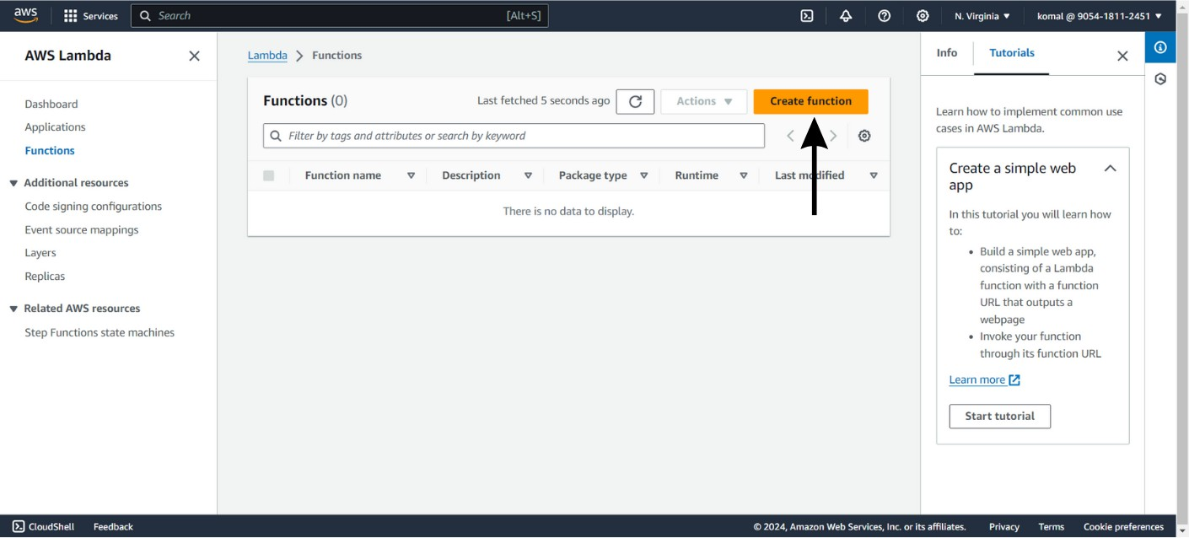

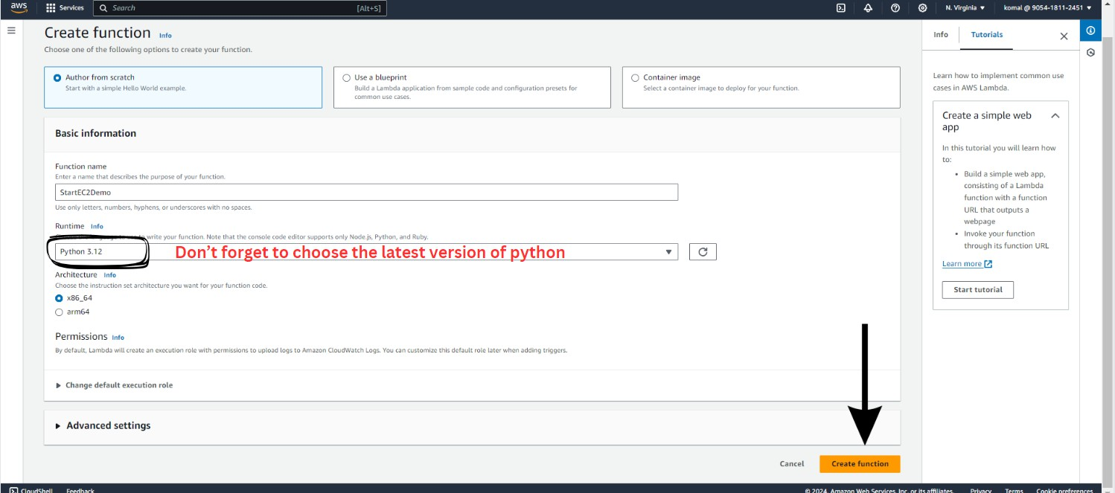

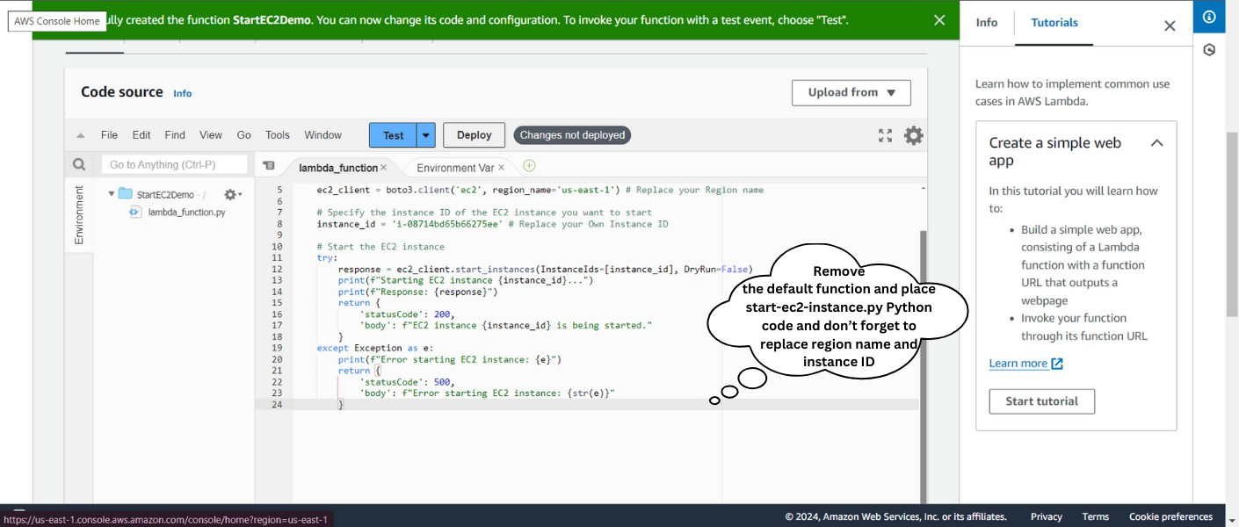

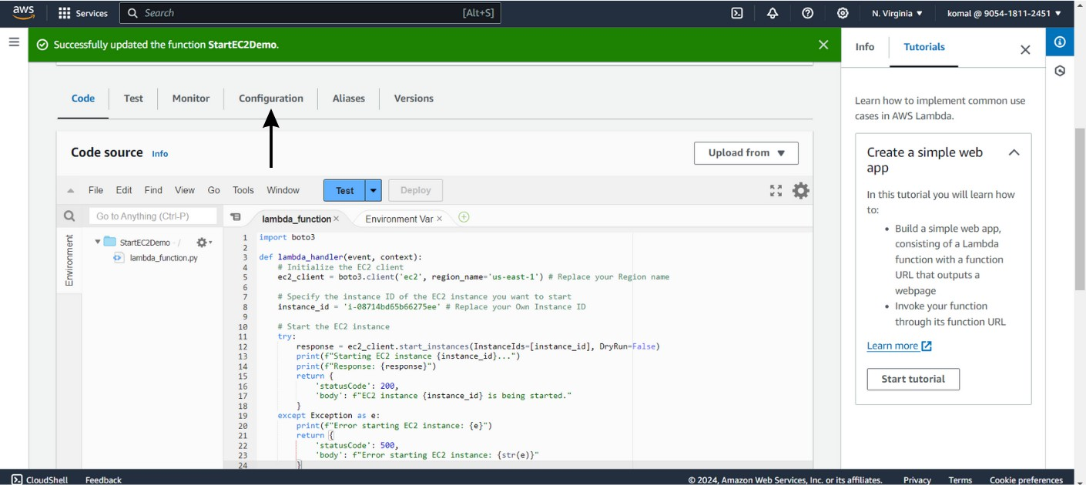
Click on deploy, after writing the code.

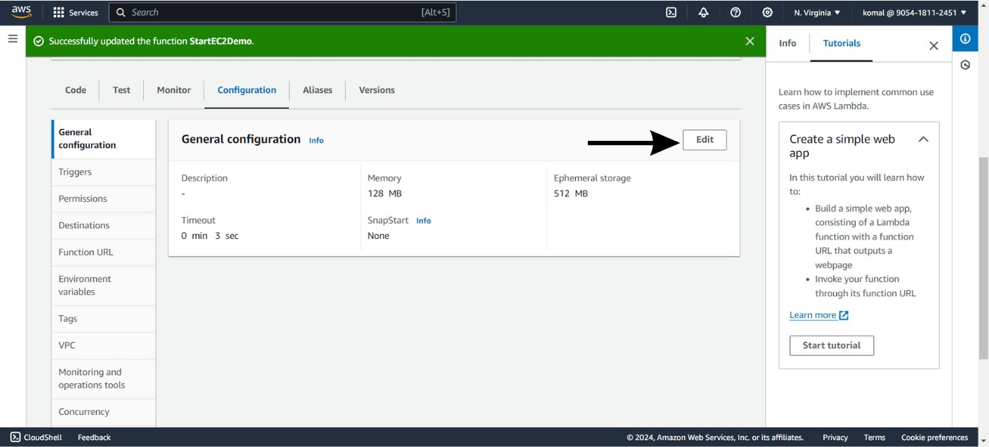
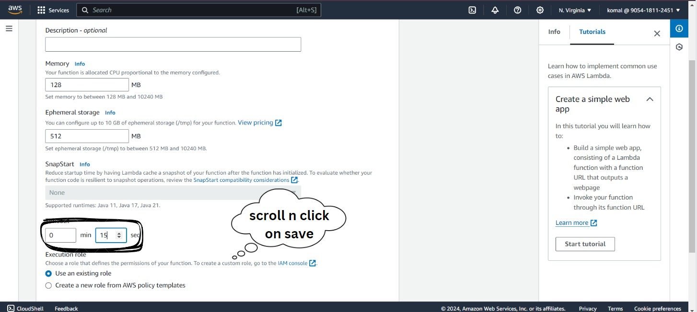

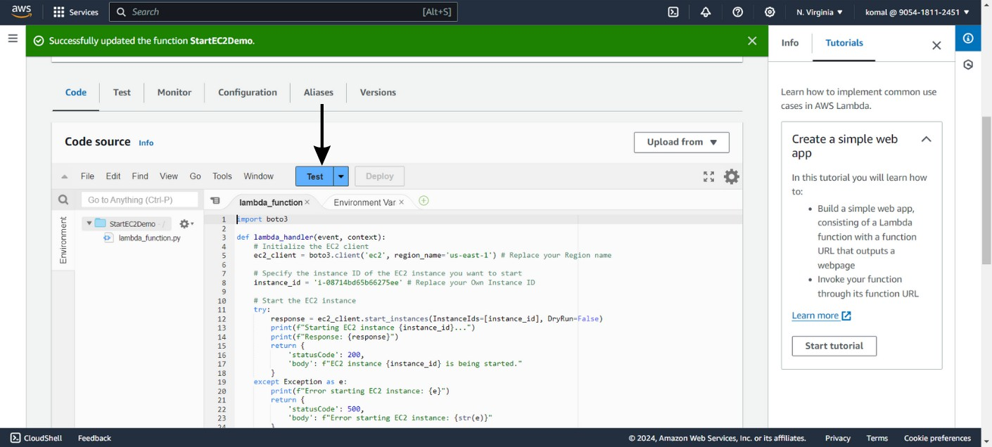


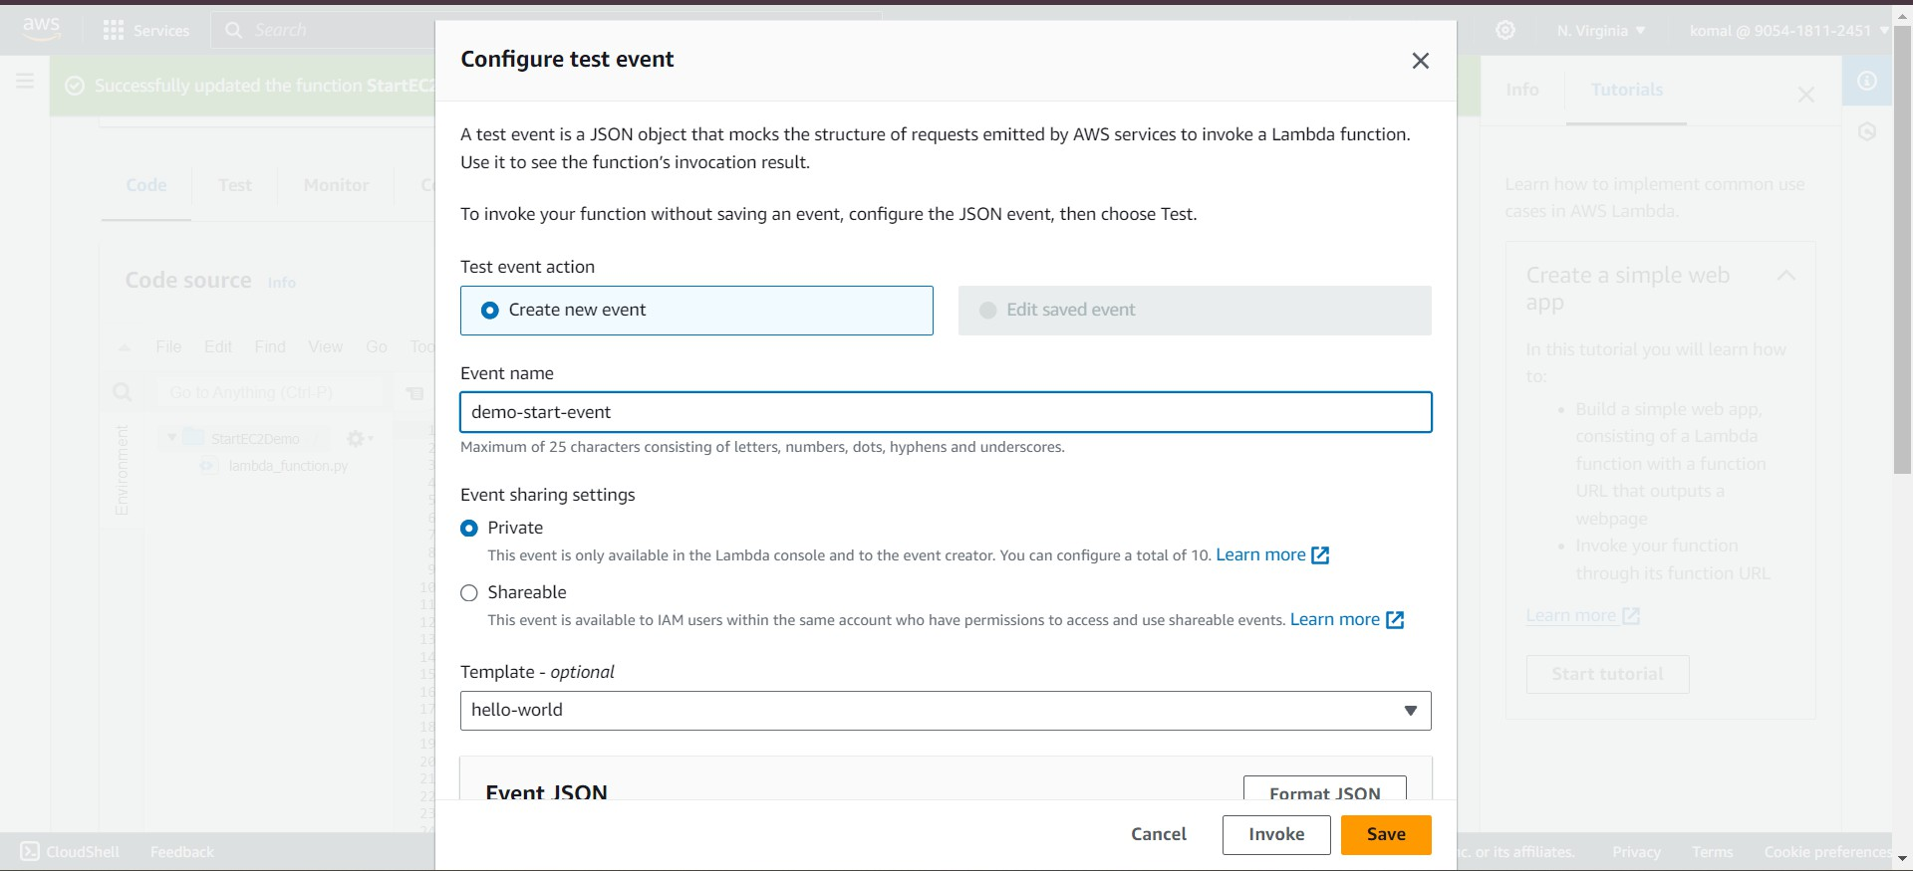Click on save

Click on the highlighted link



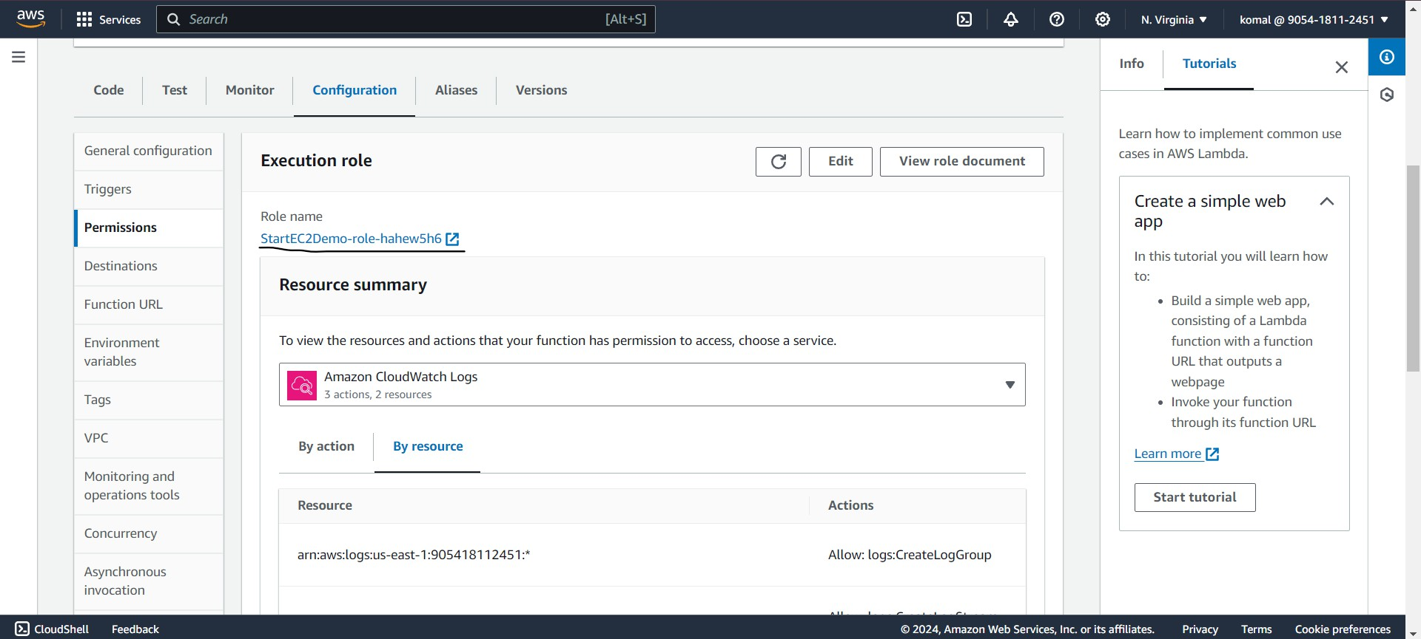

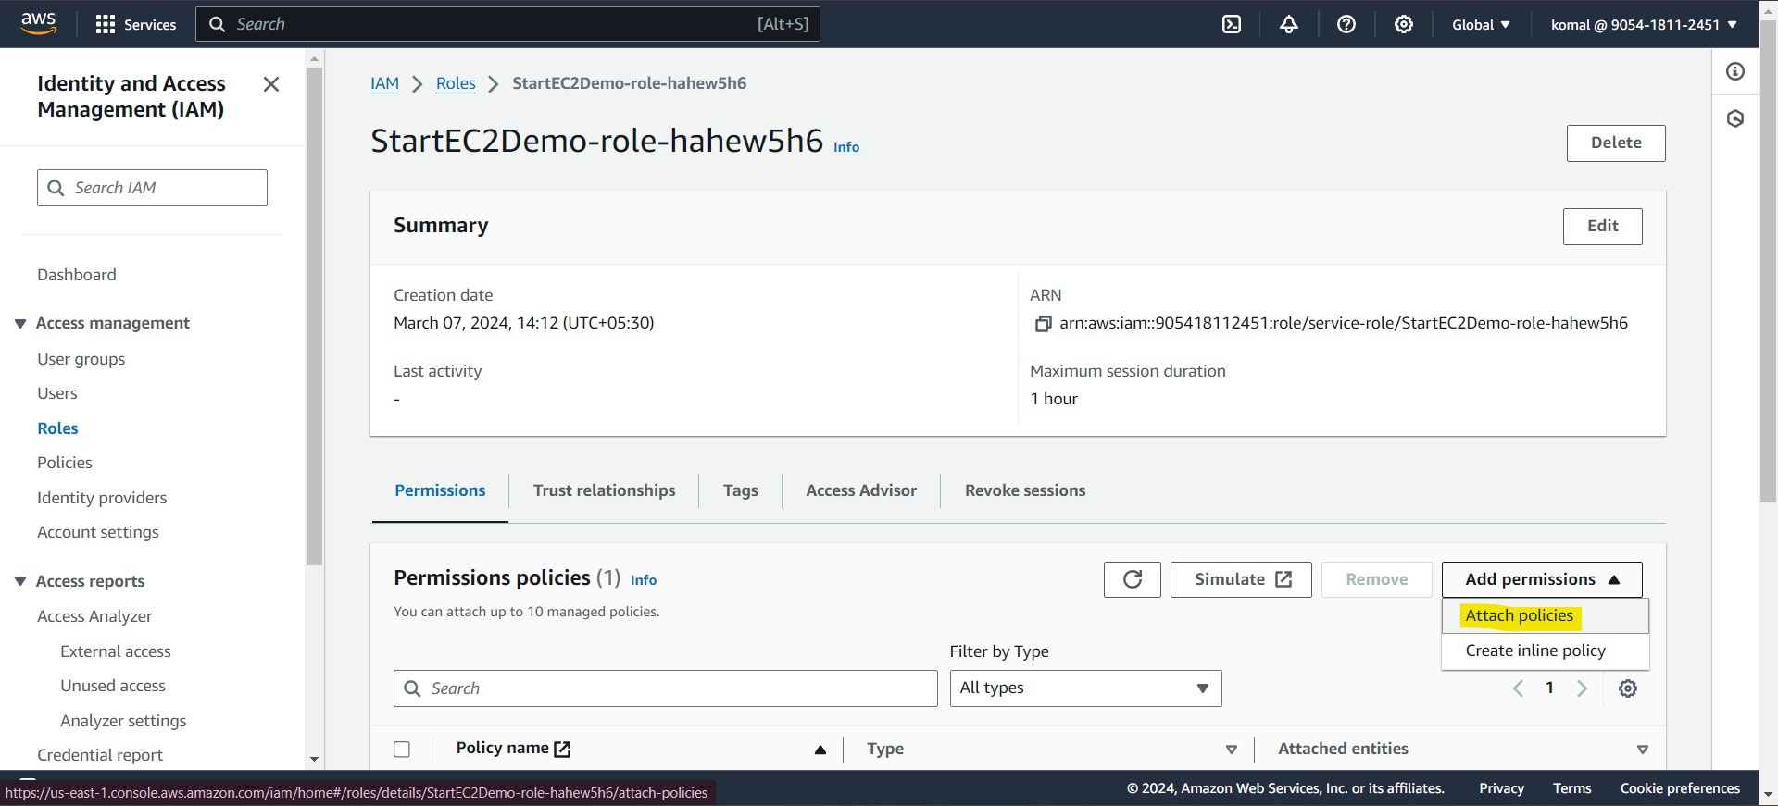

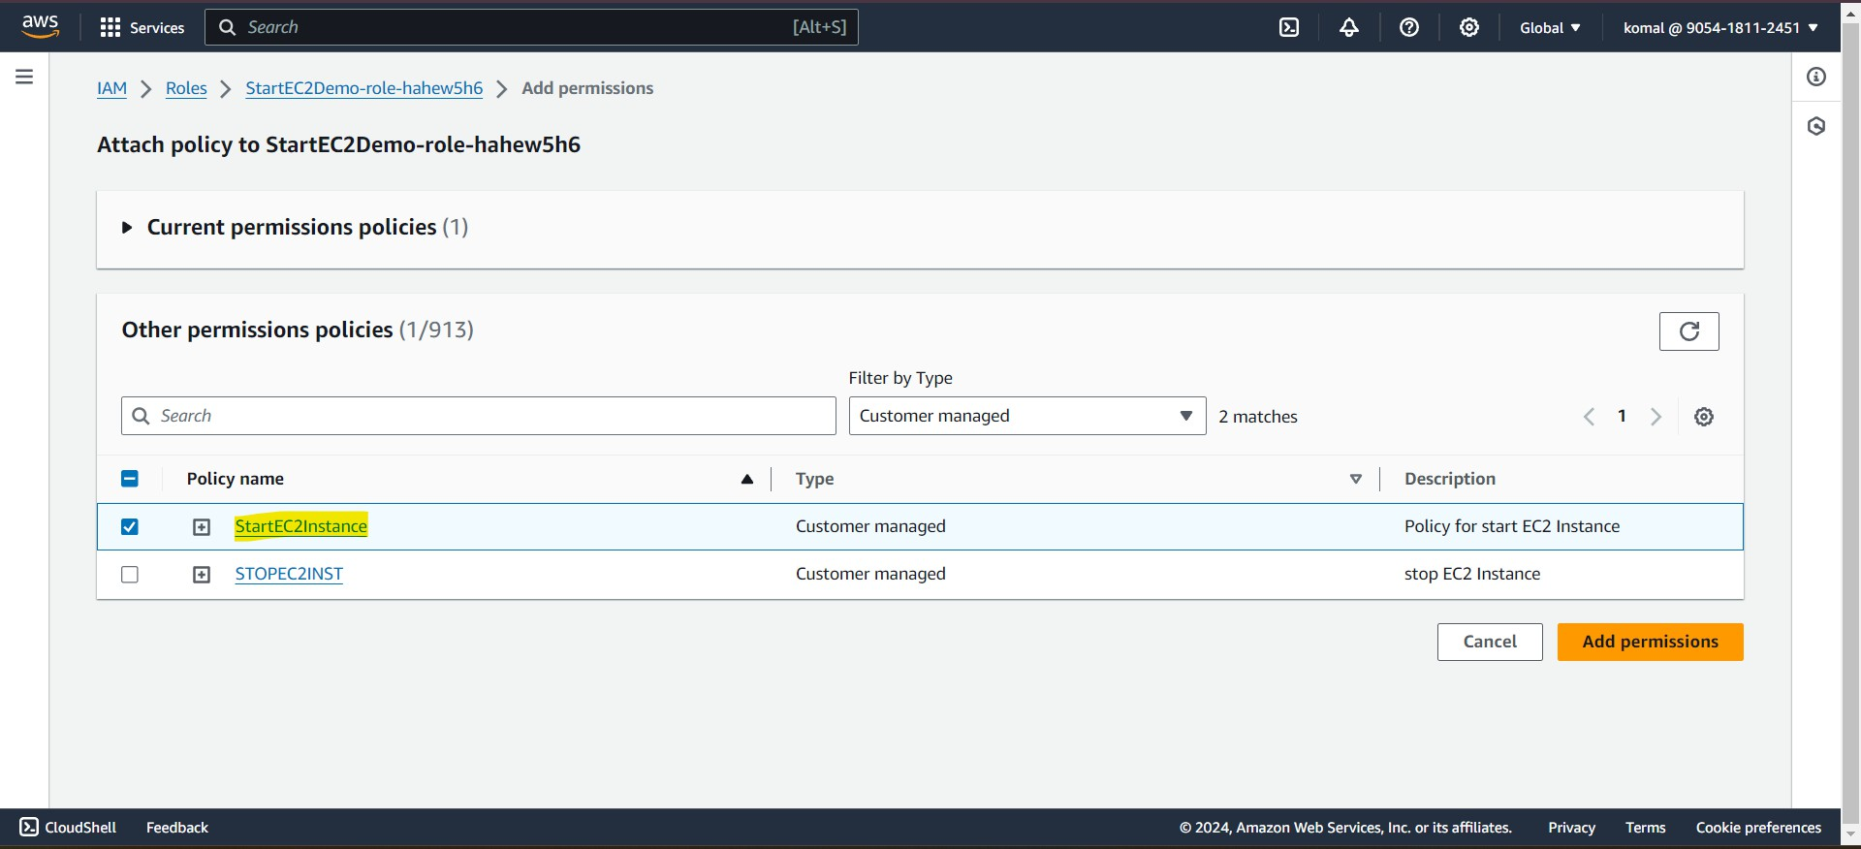

Now again , go to the Lambda console and then test the code
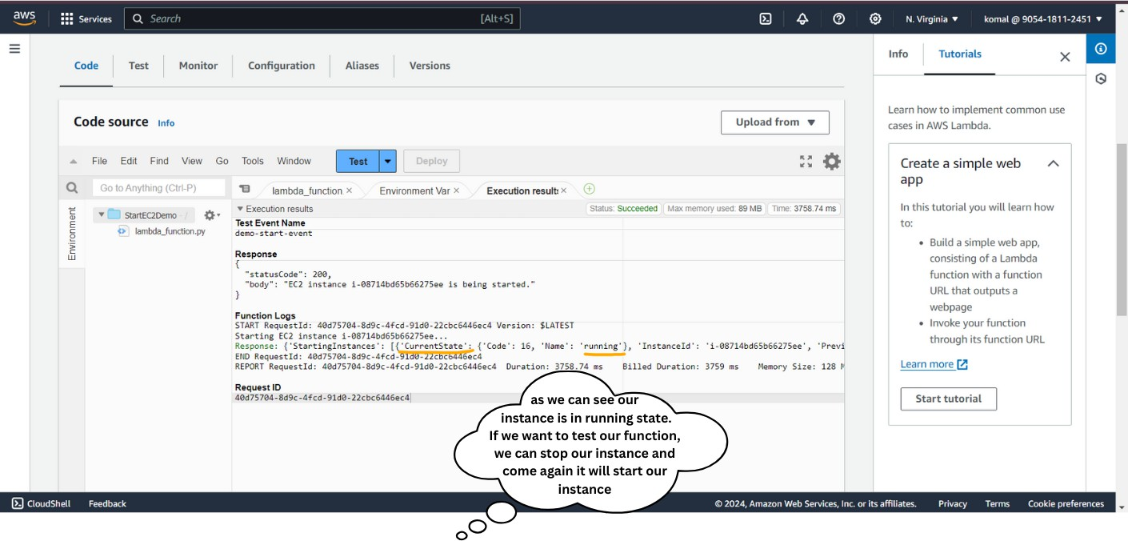

- Now we Created alambda function for Starting Instance.
- We have to Reapeat the same steps again to Create a Lambda function for 5 stopping Instance , Keep your lambda function name as "Stop-EC2-demo".
- The only changes we have to make are to replace the default code with the 'stop-ec2-instance.py' code and attach the policy we created for stopping instances to the role of this Lambda function.
- As demonstrated above, when I test my Python code, it runs successfully and stops the instance.
- Now, we are ready to proceed and create schedules for this functions

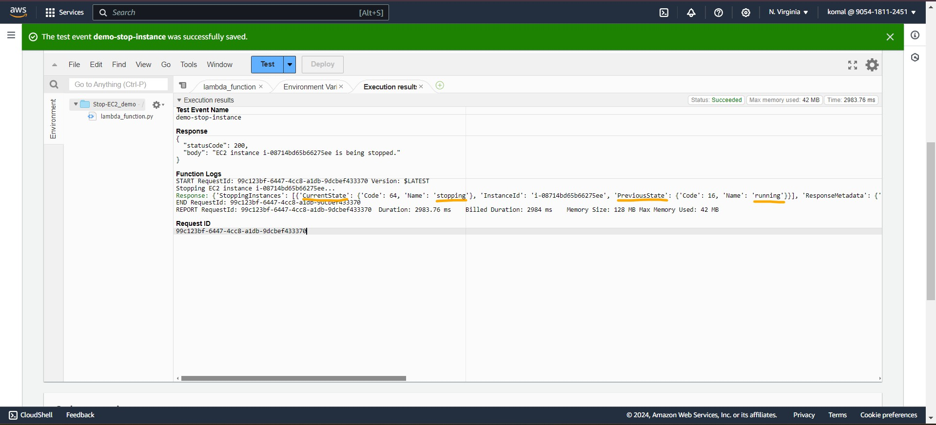
🌟Step 5:
➡Setting Up Schedules with CloudWatch:
Go to the CloudWatch Console.
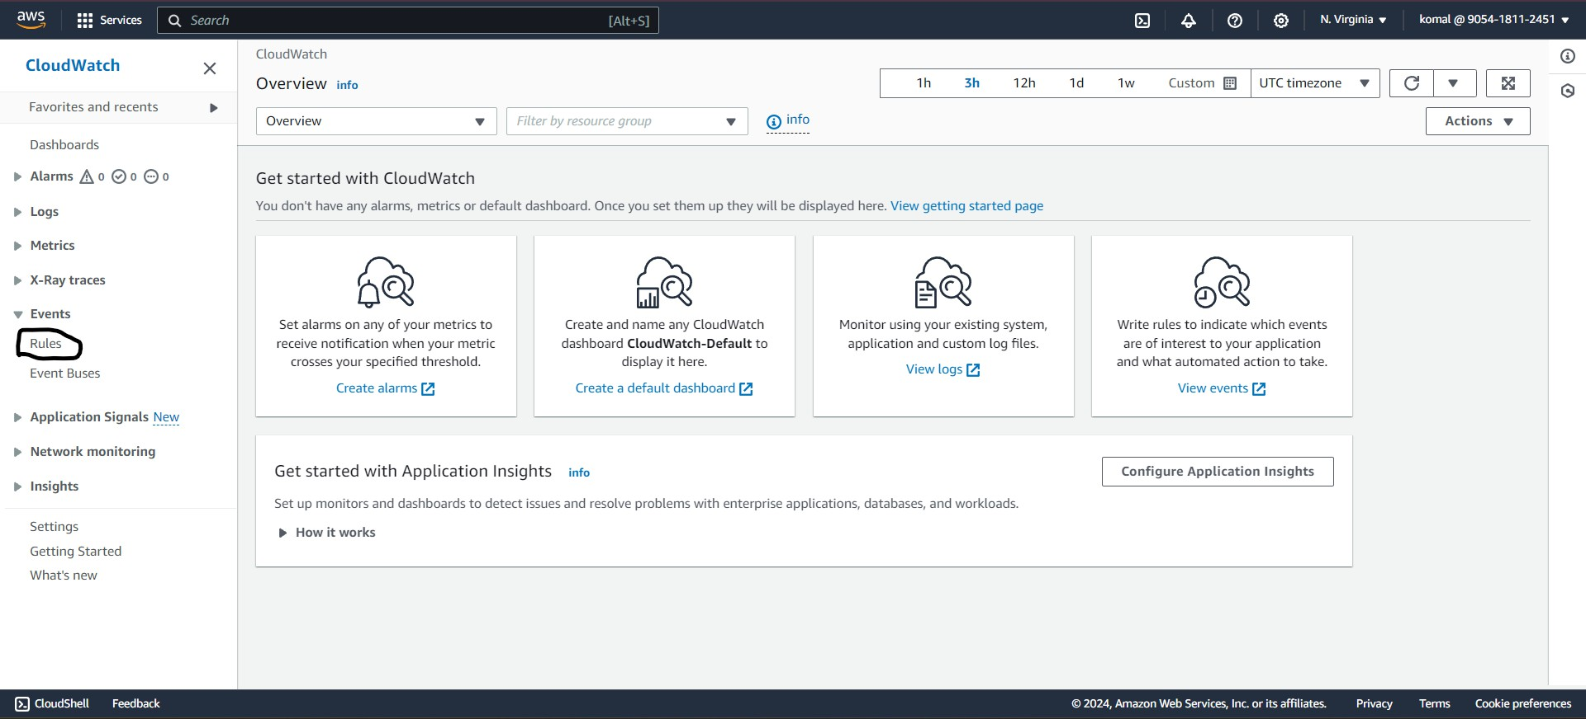
Follow the outlined steps below.

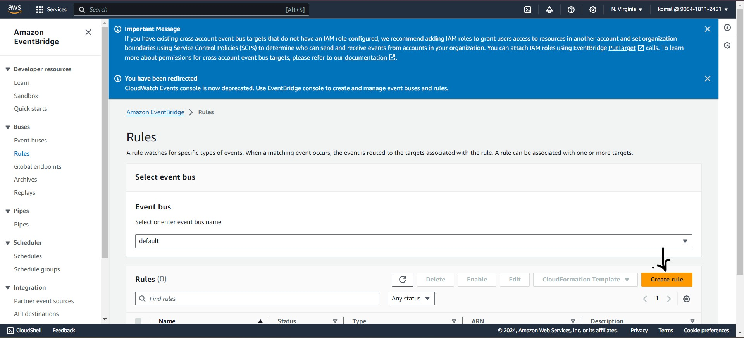

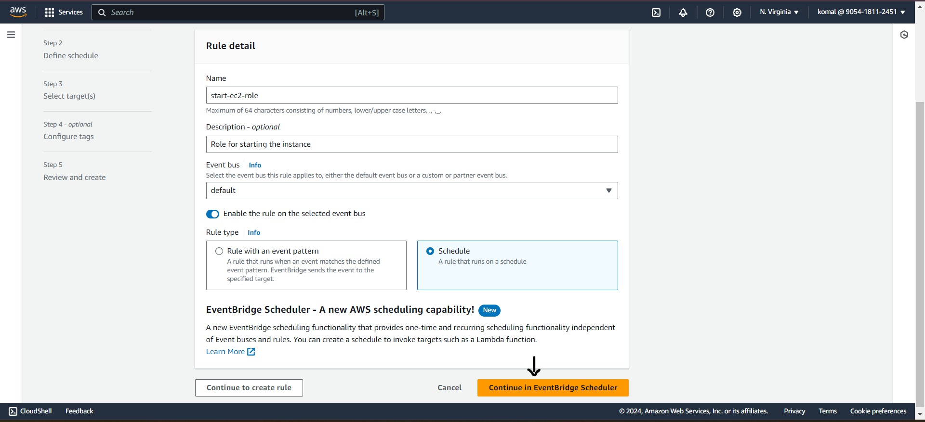

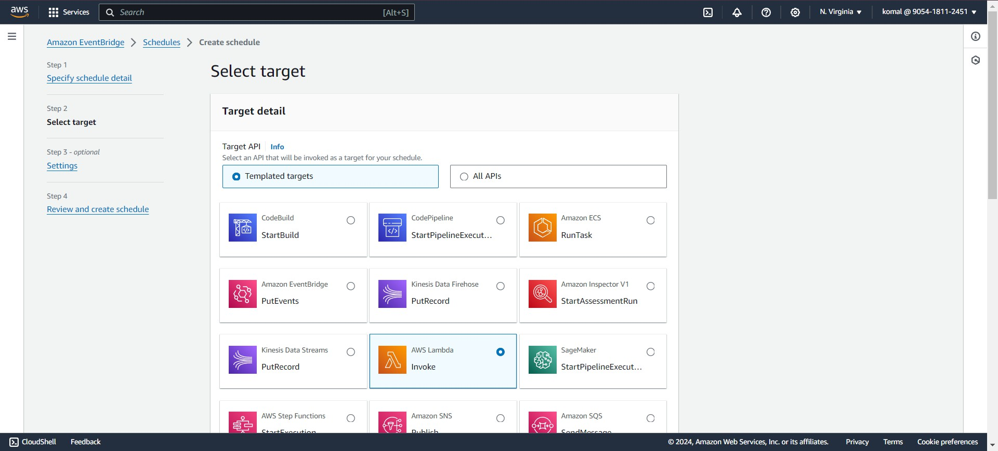

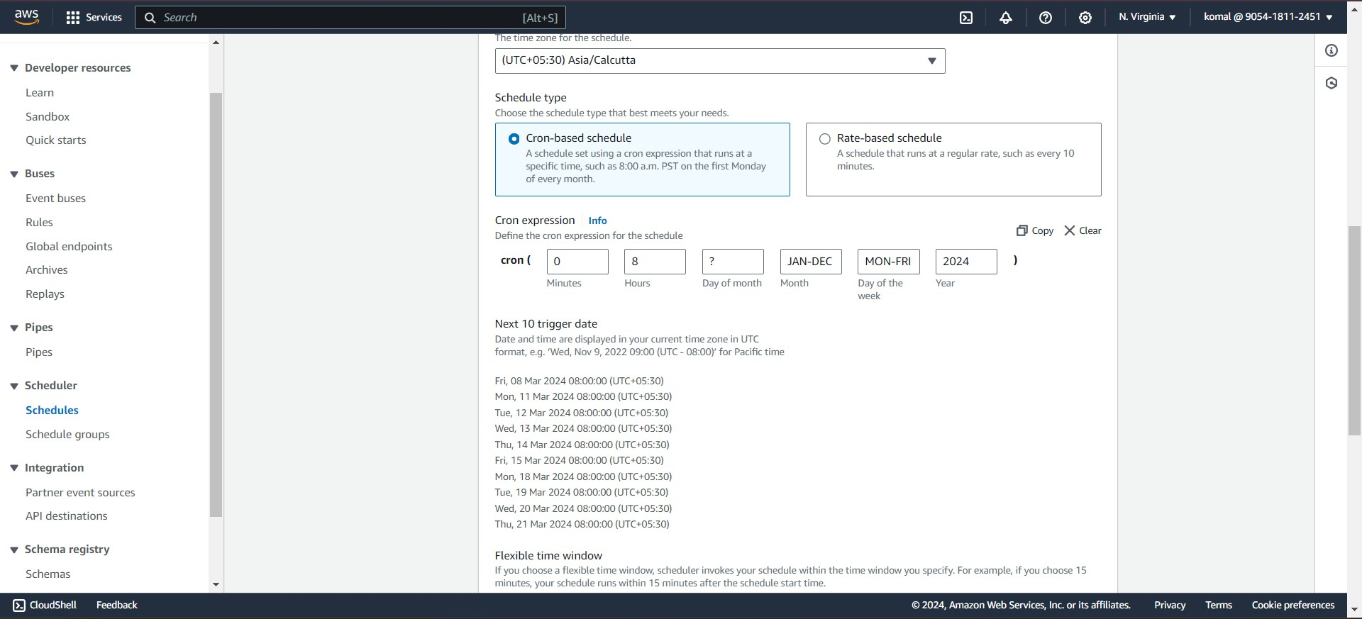

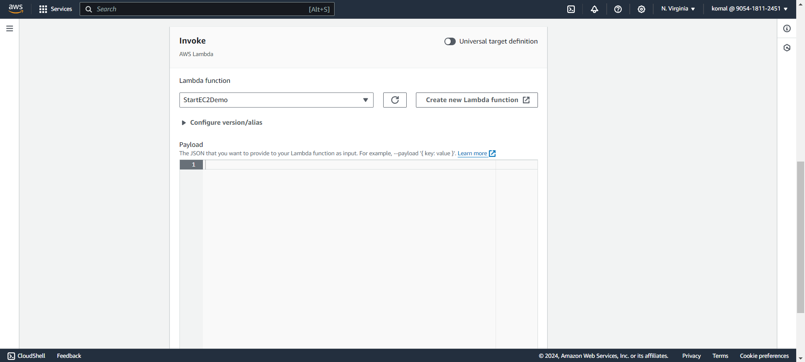

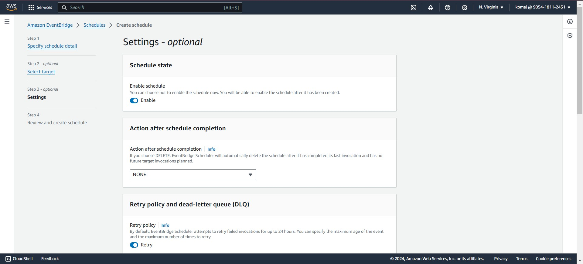

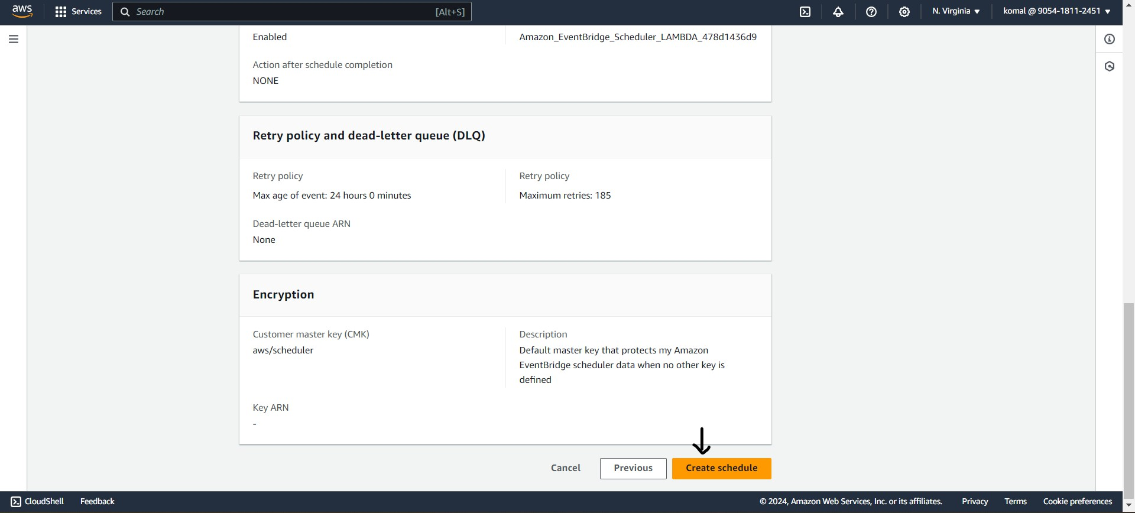
- We have now created a schedule for starting the instance every day at 8:00 AM.
- Next, we need to create a schedule for stopping instances.
- To create the schedule for stopping instances, follow the same steps as for starting instance scheduling with a few changes, Keep your rule name as "stop-ec2-rule".
- The changes include modifying the scheduled time and selecting the appropriate scheduling function.
- We need to change the schedule time to 17:00 because it will stop the Lambda function at 17:00 IST (5:00 PM).

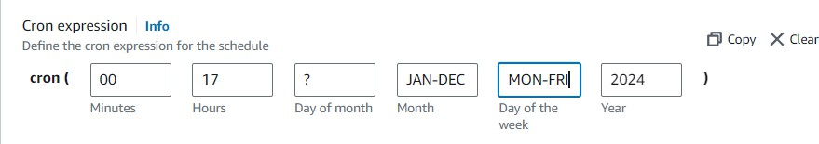

- We have to Change the Function as Stop-EC2-demo
- Now, we have successfully created two schedules: one to start the instance every day and one to stop the instance every day

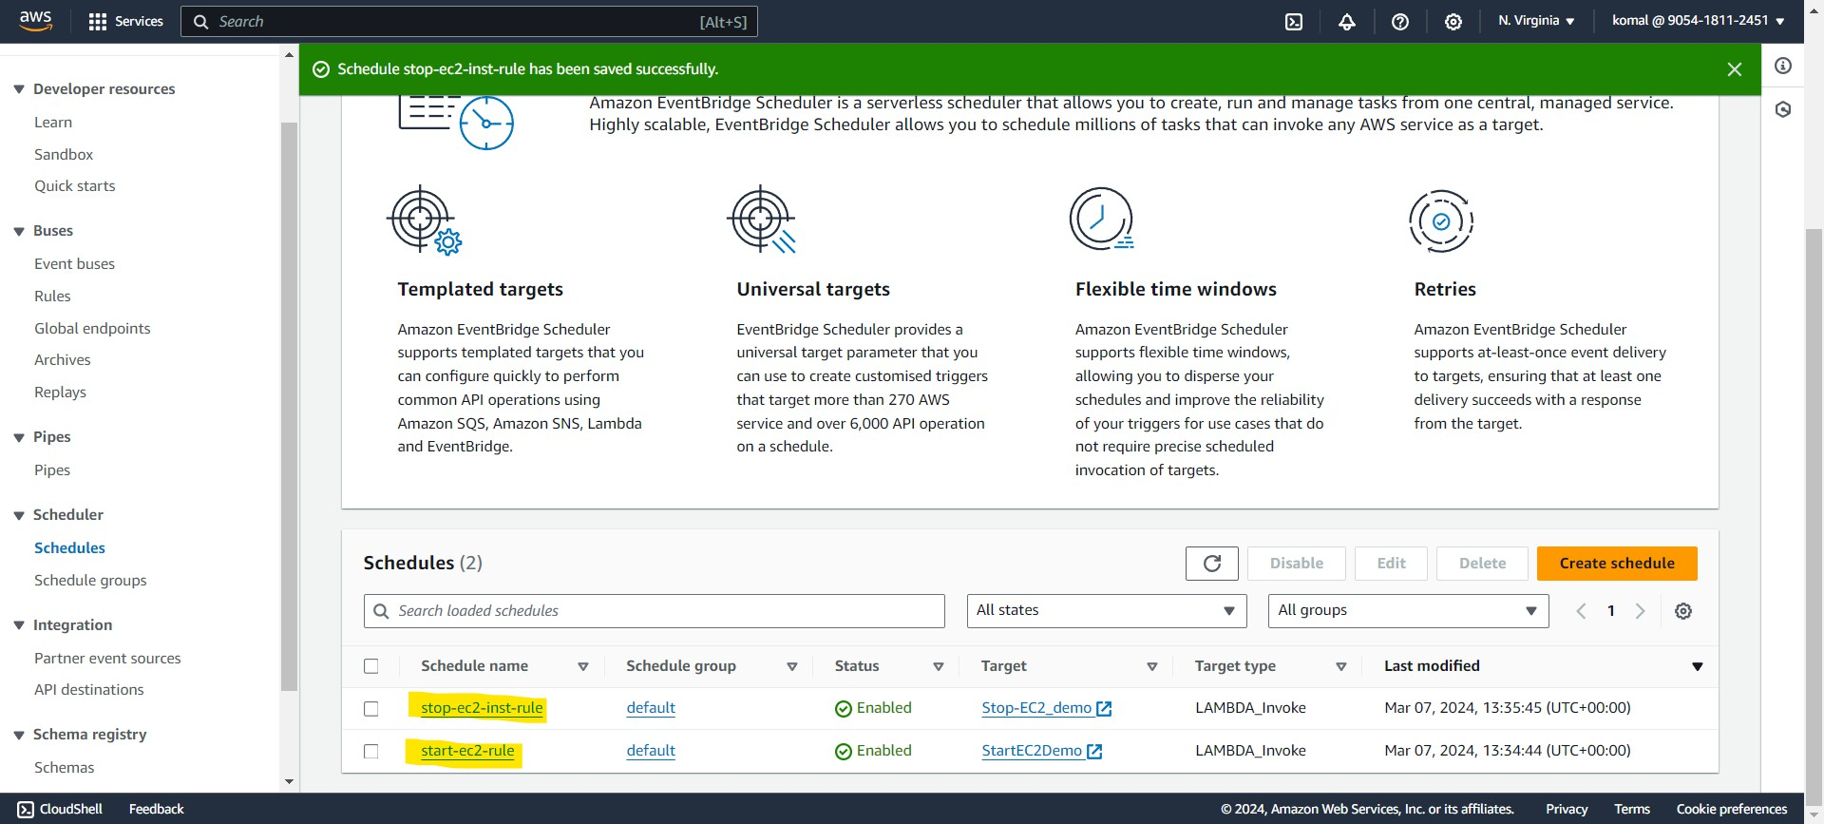

start-ec2-instance.py

import boto3

def lambda_handler(event, context):
# Initialize the EC2 client
ec2_client = boto3.client('ec2', region_name='ap-south-1') # Replace your Region name

# Specify the instance ID of the EC2 instance you want to start instance_id = 'i-051262059d6f6350a' # Replace your Own Instance ID

# Start the EC2 instance try:
response = ec2_client.start_instances(InstanceIds=[instance_id], DryRun=False) print(f"Starting EC2 instance {instance_id}...")
print(f"Response: {response}") return {
'statusCode': 200,
'body': f"EC2 instance {instance_id} is being started."
}
except Exception as e:
print(f"Error starting EC2 instance: {e}") return {
'statusCode': 500,
'body': f"Error starting EC2 instance: {str(e)}"
}

start-ec2-instance.py

import boto3

def lambda_handler(event, context):
# Initialize the EC2 client
ec2_client = boto3.client('ec2', region_name='ap-south-1') # Replace your Region name

# Specify the instance ID of the EC2 instance you want to stop instance_id = 'i-051262059d6f6350a' # Replace your Own Instance ID

# Stop the EC2 instance try:
response = ec2_client.stop_instances(InstanceIds=[instance_id], DryRun=False) print(f"Stopping EC2 instance {instance_id}...")
print(f"Response: {response}") return {
'statusCode': 200,
'body': f"EC2 instance {instance_id} is being stopped."
}
except Exception as e:
print(f"Error stopping EC2 instance: {e}") return {
'statusCode': 500,
'body': f"Error stopping EC2 instance: {str(e)}"
}

